**Film Grain(胶片纹路)**

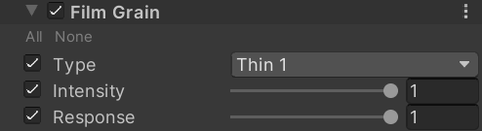

Type

The type of grain to use. You can select a preset or provide your own texture by selecting Custom.

Intensity

Amount of vignetting on screen.

Response

Controls the noisiness response curve based on scene luminance. Higher values mean less noise in light areas.

Texture

A tileable texture to use for the grain. The neutral value is 0.5 where no grain is applied.

How：

half3 ApplyGrain(half3 input, float2 uv, TEXTURE2D_PARAM(GrainTexture, GrainSampler), float intensity, float response, float2 scale, float2 offset)

{

    half grain = SAMPLE_TEXTURE2D(GrainTexture, GrainSampler, uv * scale + offset).w;

    grain = (grain - 0.5) * 2.0;

    float lum = 1.0 - sqrt(Luminance(input));//亮度越高，lum越低

    lum = lerp(1.0, lum, response);//response越大，lum越小

    return input + input * grain * intensity * lum;

}